H.T No
Regulations:
A22

Sreenidhi Institute of Science and Technology
(An Autonomous Institution)
Code No:9HC11 Date: 04-September-2024 (AN)

B.Tech I-Year I- Semester External Examination, September-2024 (Supplementary)
MATRIX ALGEBRA AND CALCULUS (COMMON TO ALL)

Time: 3 Hours Max.Marks:60

Note: a) No additional answer sheets will be provided.
b) All sub-parts of a question must be answered at one place only, otherwise it will not be valued.
c) Missing data can be assumed suitably.
Bloom's Cognitive Levels of Learning (BCLL)

Remember | L1 | Apply | L3 | Evaluate | L5
Understand | L2 | Analyze | L4 | Create | L6

Part - A Max.Marks: 6x2=12

Answer all QUESTIONS, EACH QUESTION CARRIES 2 MARKS.

 |  | BCLL | CO(s) | Marks
1 | Find the value of k, if rank of matrix A is 2, where 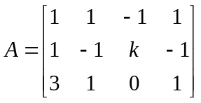 | L2 | CO1 | [2M]
2 | Find the characteristic polynomial of the following matrix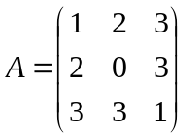 | L1 | CO2 | [2M]
3 | Find the nature, index, signature, and rank of the following Quadratic form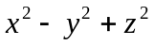 | L2 | CO3 | [2M]
4 | Check the applicability of Rolle’s theorem for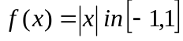 | L2 | CO4 | [2M]
5 | Define Law of natural Growth and Decay | L1 | CO5 | [2M]
6 | Find the particular Integral of 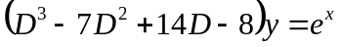 | L2 | CO6 | [2M]

Part – B Max.Marks: 6x8=48
ANSWER ALL QUESTIONS. EACH QUESTION CARRIES 8 MARKS.

 |  |  | BCLL | CO(s) | Marks
7. |  | Find Rank of matrix of the following matrices by reducing to Echelon form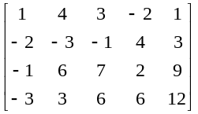 | L2 | CO1 | [8M]
 |  | OR
8 |  | Discuss for what values of 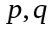 the simultaneous equations  have  (i) no solution (ii) a unique solution (iii) an infinite number of solutions. | L3 | CO1 | [8M]
9. |  | Verify Cayeley Hamilton theorem hence find 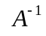 if 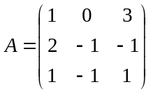 | L3 | CO2 | [8M]
 |  | OR
10 |  | Reduce the matrix 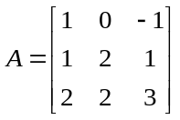 to diagonal form by using modal matrix of A | L4 | CO2 | [8M]
11. |  | Reduce the Quadratic form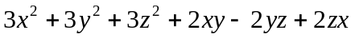  To canonical form by Diagnalization transformation hence Find the nature, index, signature and rank | L3 | CO3 | [8M]
 |  | OR
12 |  | Reduce the Quadratic form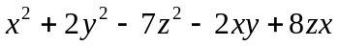  To canonical form by Lagrange’s method hence Find the nature, index, signature and rank | L3 | CO3 | [8M]
13. |  | Verify Cauchy’s theorem for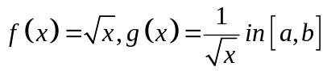 | L2 | CO4 | [8M]
 |  | OR
14 |  | Apply Lagrange’s mean value theorem to prove that 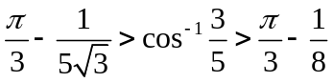 | L3 | CO4 | [8M]
15. |  | Solve 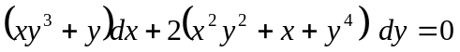 | L3 | CO5 | [8M]
 |  | OR
16 |  | If the air is maintained at 30⁰c and the temperature of the body cools from 80⁰C to 60⁰c in 12 minutes, find the temperature of the body after 24 minutes? | L3 | CO5 | [8M]
17. |  | Solve the second order linear differential equation 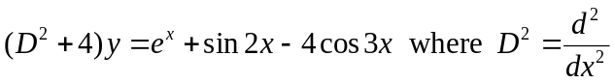 | L4 | CO6 | [8M]
 |  | OR
18 |  | Solve the differential equation 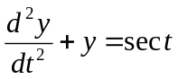 by the method of variation of parameters. | L4 | CO6 | [8M]

-- 00 -- 00 –

